

|  |  |  |  |  |  |  |  |  |
| --- | --- | --- | --- | --- | --- | --- | --- | --- |
|  | | | | | | | | |
|  | | The Battle of Neighborhoods | | | | |  | |
|  |  | | | | | | |  |
|  | | | |  |  | | | |
|  | | | | ChanderBijlani |  | | | |
|  | | | | 29 November 2020—Applied Data Science Capstone—IBM/Coursera |  | | | |
|  | | |  | | |  | | |



|  |  |  |  |  |  |  |  |  |
| --- | --- | --- | --- | --- | --- | --- | --- | --- |
|  |  | | |  |  | | |  |
|  | Table Of Contents | | | | | | |  |
|  |  | | |  |  | | |  |
|  |  | |  | | |  | |  |
|  |  |  | * INTRODUCTION * DATA * METHODOLOGY * RESULTS AND DISCUSSION * CONCLUSION | | |  |  |  |
|  | | | | |
|  |  |  |  |
|  |  |



|  |  |  |  |  |  |  |  |  |
| --- | --- | --- | --- | --- | --- | --- | --- | --- |
|  | |  |  |  |  | | | |
|  | | INTRODUCTION | | |  | | | |
|  | |  |  |  |  | | | |
|  | PROBLEM DESCRIPTION Delhi, the capital of India is known for its food culture and rich lifestyle. It is influenced by the food habits of its residents and is where Mughlai cuisine originated. It includes a variety of international cuisines which are popular among the residents along with Indian cuisine.  So the aim of this project is to find a suitable location in Delhi for a person who is looking to open his restaurant so that it gets people attention and can earn good profit to survive this competitive market and also for food delivering companies to look for popular food restaurants. | | | | | | |  |
|  | Background Discussion: | | | | |  |  |  |
|  | Delhi ranks 62 in list of world’s best cities. The dearth of food habitsamong the delhi's residents created a unique style of cooking which became popular throughout the world, with dishes such as kebab,  biryani, tandoori. The city's classic dishes include butter chicken,  dal makhani, shahi paneer, aloo chaat, chaat, dahi bhalla, kachori,  gol gappe, samosa, chole bhature, chole kulche, gulab jamun, jalebi and lassi. | | | | |  |  |  |

|  |  |  |  |  |  |  |
| --- | --- | --- | --- | --- | --- | --- |
|  | Stakeholders/Target Audience | | | | |  |
|  | |  |  |  |  | |
|  | This detailed analysis can be used by a person to find the food hotspots in Delhi for opening his/her restaurants or by food delivering companies to look for popular food restaurants. | | | | |  |

|  |
| --- |
| **DATA** |

The data that can be used to solve our problem or the factors that can influence to solve our problem are:

1. Delhi Neighbourhoods dataset from kaggle :

This [dataset](https://https/www.kaggle.com/shaswatd673/delhi-neighborhood-data?select=restaurant_dataSet.csv) contains information about neighbourhoods in the Delhi such as their name, borough, location, etc.

1. Creating a location dataset using foursquare api which will give us the most common venues to establish/open our restaurant.
2. Using Folium library to create interactive visualization maps of popular or most common venues.

|  |
| --- |
| **DATA CLEANING AND PREPROCESSING** |

* After performing this stage, we got our cleaned data frame:

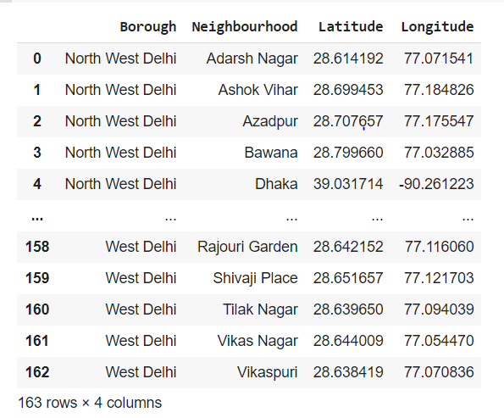

|  |
| --- |
| **Methodology** |

This section is divided into two parts:

1. Exploratory Data Analysis: Visualize the neighbourhood data of Delhi using location latitude and location longitude and after normalizing the data, we explored the 10 most common venues for setting up restaurant.
2. Modelling: Helping stakeholders find the right neighborhood within a borough we will be clustering similar neighborhoods using K - means clustering which is a form of unsupervised machine learning algorithm that clusters data based on predefined cluster size. We will use K-Means clustering to address this problem so as to group data based on existing venues which will help in the decision making process.

|  |
| --- |
| **VISUALIZATIONS** |

* Delhi map using latitude and longitude.

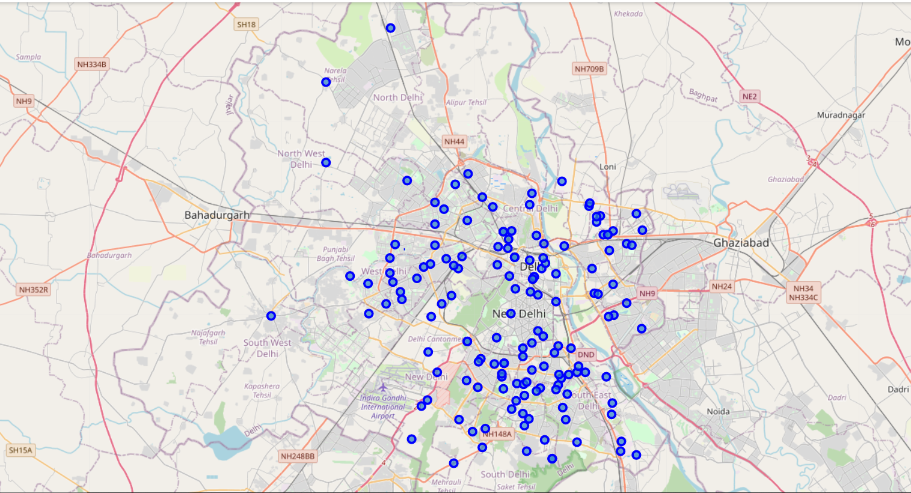

* Clustered neighbourhoods on the basis of most common venues in delhi

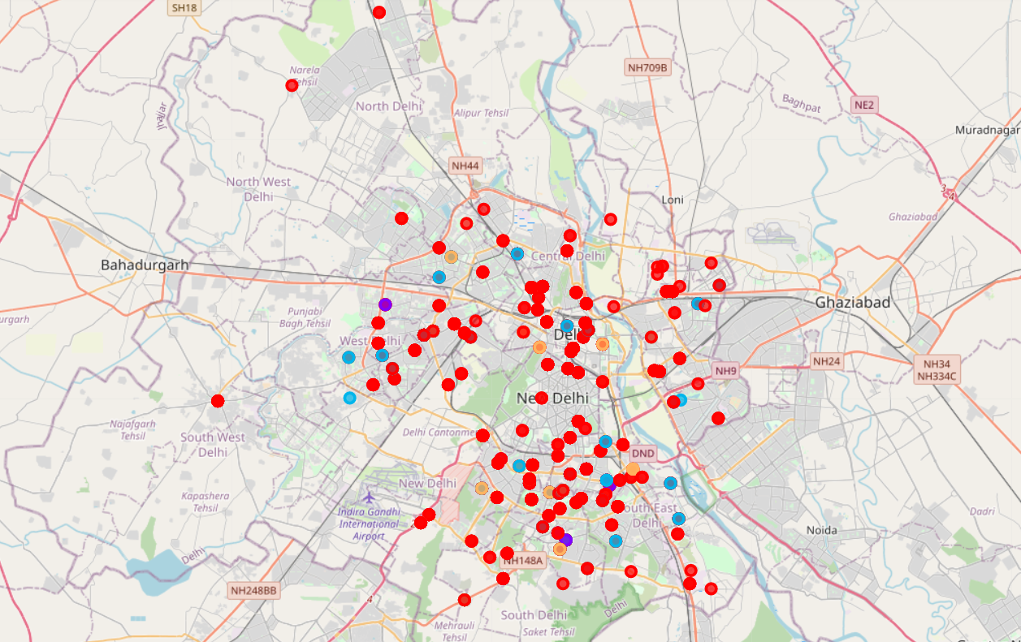

|  |
| --- |
| **RESULTS AND DISCUSSION** |

The objective of this business problem was to identify a suitable location for the stakeholders to open a restaurant where they can gain huge profit and can survive the market. Here in the analysis, we found the 10 most common venues in neighbourhood in Delhi and with the help of KMeans clustering algorithm we made neighborhood clusters of Delhi and visualized in the form of iteractive map to show us this venues and in a way helping the stakeholders to find a good place to set up their restaurant.

|  |
| --- |
| **Conclusion** |

Through the analysis of neighborhood data of Delhi we found out the 100 top venues of neighborhoods and after normalizing our data we found the 10 most common venues that are good and profitable for opening a restaurant.